
STUDENT CASE STUDY EXECUTION REPORT
Department | FED
Subject | DSA-2
Academic Year | I-III semester(2025-26)
Faculty Name | Sukanya
Student Name | Devaji Rashmika
Roll Number | 2520090152
Branch | CSIT
Course Outcome

Case Study Topic: Tata Steel pipeline network — maximum oil-flow rate from refinery to depot
Work Done Summary:
In this case study, we implemented the Edmonds–Karp BFS-based Ford–Fulkerson algorithm to determine the maximum oil-flow rate in a Tata Steel-Petrochem pipeline network. The network contains 6 nodes and 9 directed edges with capacities measured in kilolitres/hour. We repeatedly searched for augmenting paths using BFS and updated residual capacities after every iteration. We observed bottleneck-flow calculations, forward-edge reduction, and reverse-edge creation in the residual graph. The final maximum flow obtained from refinery source S to depot sink T was 18 kL/hour.
Implementation Details:
- Constructed the directed pipeline network with capacities.
- Applied BFS to find augmenting paths from S to T.
- Computed bottleneck flow using minimum residual capacity.
- Updated forward and reverse residual edges after every augmentation.
- Repeated iterations until no augmenting path remained.
- Analysed Edmonds–Karp time complexity O(VE²).

Result: Screenshots / Output:
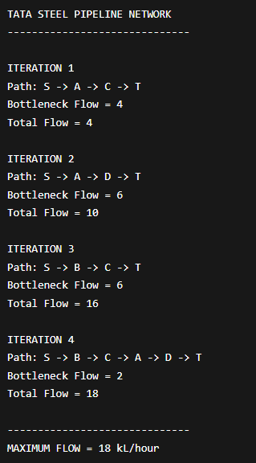
Iteration 1
Path found:
$$S→A→C→T$$
Bottleneck:
$$min⁡(10,4,10)=4$$
Total Flow = 4
Iteration 2
Path found:
$$S→A→D→T$$
Bottleneck:
$$min⁡(6,8,10)=6$$
Total Flow = 10
Iteration 3
Path found:
$$S→B→C→T$$
Bottleneck:
$$min⁡(10,9,6)=6$$
Total Flow = 16
Iteration 4
Path found:
$$S→B→C→A→D→T$$
Bottleneck:
$$min⁡(4,3,4,2,4)=2$$
Total Flow = 18

No further augmenting path exists in the residual graph.
Maximum Flow:
$$\boxed{18\text{ kL/hour}}$$
Time Complexity:
- Edmonds–Karp Complexity:
$$O(VE^{2})$$
- For this network:
$$V=6$$
$$E=9$$
The BFS-based shortest augmenting path approach guarantees polynomial-time execution and efficient maximum-flow computation.
GitHub Link:
Student Signature | Faculty Signature

